THE SPRINGS AT HIGH ROCK MY ZONE NUMBER IS ________
QUICK guide for EMERGENCY RESPONSE
Please print a hard copy and store IT in an easy-to-get-TO place.
The following is an abbreviated list from the Firewise tab “Emergency Fire Response and Evacuation Plan” (EFRaEP) on the community website, www.thespringsathighrock.org
It is meant to be a reminder list only to help us in a less than calming situation. Please refer to the “Emergency Fire Response and Evacuation Plan” for more detailed explanations of these suggestions.
SITUATION: If Calling Post (Section 4, EFRaEP) gives us a warning that a possible evacuation will be ordered, you should start preparing by (taken from Section 7, EFRaEP):
1. All family members presently in the community, especially young children, should report home immediately.
2. All pets in the family should be leashed or contained, so that they can be transported quickly.
3. Get your “Personal Information Packet” (PIP) and 3-day medicine supply out (discussed in Section 5,
EFRaEP).
4. Take this guide with you for further reference after leaving
5. Get your cell phone out and turn it on. Also, get both your car and home charger units out.
6. Have the vehicle(s) that you intend to leave with headed in the exit direction of your driveway.
7. Put several bottles of water in those vehicles.
8. Make sure there is a good, working flashlight in those vehicles.
9. Stay off your home landline phones so that any up-to-date Calling Post messages can be received.
10. Get everybody into a comfortable pair of walking shoes. Do not use leather sole shoes, slippers, or
moccasins. They are too slippery to walk on grass, if it comes to that.
SITUATION: An immediate evacuation has been called “Everybody leave now!” (Section 7, EFRaEP):
1. Gather the family; if there are missing members (especially children) call 911 immediately so that
information can be relayed to the fire chief and additional help can be utilized in the search.
2. Do not waste time looking for out-and-about pets or pets hiding in your home.
3. Take your “Personal Information Packet” and medicines if they have already been prepared.
4. Take this guide with you for further reference.
5. Take your cell phone and turn it on.
6. The last car/person out of your home can hang the Mailbox Signal flag letting the firefighters know that they
don’t have to worry about someone’s being left behind (Section 6, EFRaEP).

SITUATION: Evacuation, leaving via the roads (discussed in Section 8, EFRaEP):
1. The last person/vehicle leaving will hang the Mailbox Signal flag (Section 6, EFRaEP).
2. Follow the directions that the fire department gives us. They may not be the shortest route but the
safest. Remember the fire department may want us to use the emergency exit route at the
eastern end (Route 8) of Sierra Trace Road.
3. Turn on your cell phones if not already on.
4. Turn on your headlights. Use your warning blinkers if visibility is very bad.

5. Drive at a safe speed (20-25 MPH), no tailgating and two hands on the steering wheel.
6. Be alert especially for panicking deer. Everybody should be helping the driver watching out.
SITUATION: We are safely out of the community via car or truck onto Route 8 and the Sheriff’s Department is directing us to a specific location: (discussed in Section 8, EFRaEP).
1. The purpose is to report in so that the fire department knows that your family is safe. The location will
probably be Pebble Beach or Southmont Fire Station if sent north. Dave’s Mini-mart if sent south.
2. Find Zone recorders with clipboards and wearing yellow or orange vests and report in.
SITUATION: The main gate is blocked (discussed in Section 9, EFRaEP), and the firefighters cannot get in to guide us:
1. Rocky Cove Lane residents should go to community docks #2 and #3, private docks, or shoreline. They
should not try to go to community dock #1 since that would be going towards the fire. If you park your car,
park it as far off of the road as possible; do not block the road!
2. Healing Springs Drive residents should go to community dock #1, private docks, or shoreline.
3. Those residents on the top of the mountain must decide for themselves whether it is better to stay or try to get
down the mountain. If you decide or you are advised to stay via Calling Post, try to get to the HOA
clubhouse (It offers a wide-open space and large water source from the swimming pool).
4. The very last resort is to stay in your home.
SITUATION: You have evacuated by your boat and are picking up evacuees from the shoreline or docks:
1. Call 911 to tell them you are safe and what you are doing. 911 will relay to the fire chief
2. Get instructions on where to drop your passengers off and report their names as soon as possible.
3. Don’t overload your vessel.
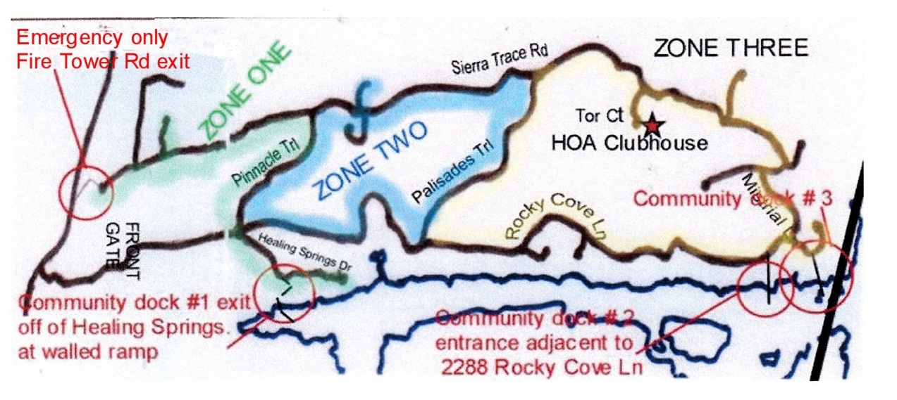
October 4, 2020

